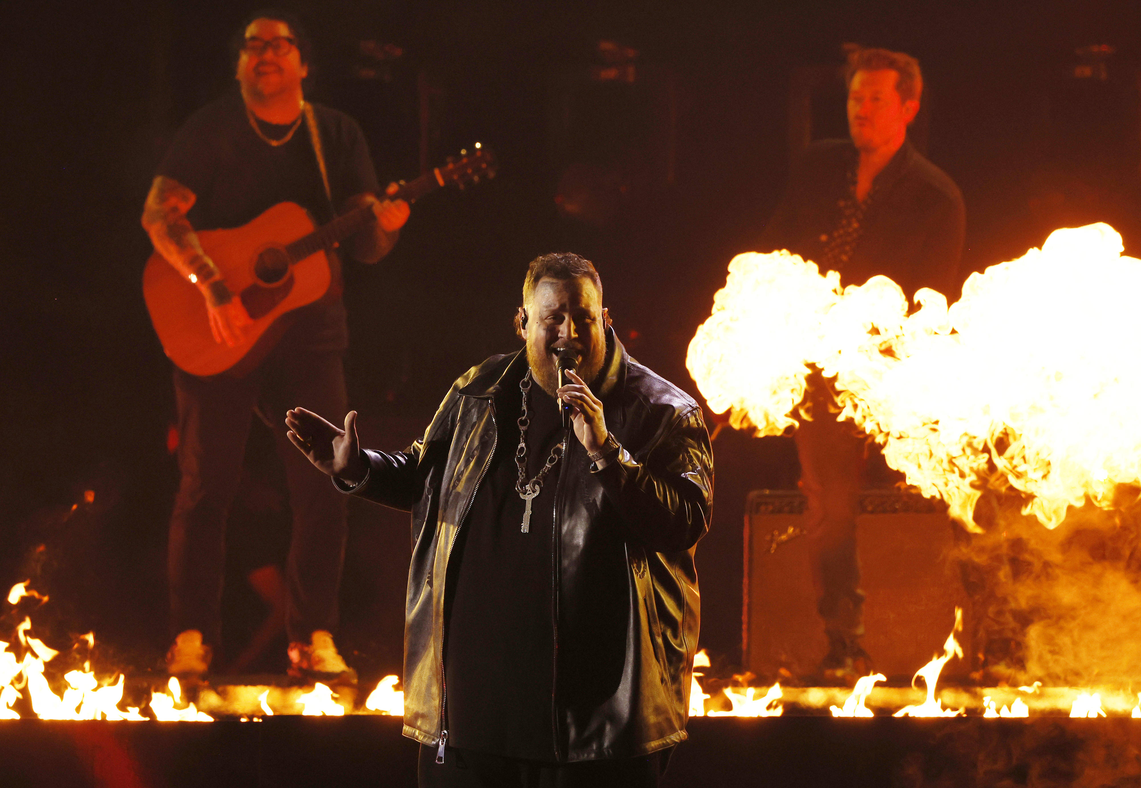

Image Source IMAGO / UPI Photo

Jelly Roll, Kelsea Ballerini, and Post Malone Rely on Sennheiser to Deliver Stellar Performances at the 2024 CMA Awards

Sennheiser’s MMD 935 dynamic cardioid microphone capsule and Digital 6000 System continue to be artists’ choice for premium sound quality and reliability

Nashville, TN – December 5, 2024 – The 58th annual CMA Awards took place on November 20th, airing live from Nashville’s Bridgestone Arena. Hosted by Luke Bryan, Peyton Manning and Wilson, it was a successful night celebrating country music and its biggest stars. What made the ceremony extra special were the performances, most notably by Jelly Roll, Kelsea Ballerini and Post Malone, whose teams all deployed custom Sennheiser microphones and the Digital 6000 wireless system. Jelly Roll used an MMD 935 dynamic cardioid microphone, Ballerini used an MD 9235 dynamic microphone capsule and Post Malone used an MM 435 capsule – all of which helped to complement each artist’s voice and elevate their performances to the next level.

A celebratory night packed with unforgettable performances
A highlight of the night was Jelly Roll, who was nominated for Entertainer of the Year, Album of the Year (for 2023’s Whitsitt Chapel), and Male Vocalist of the Year. The Tennessee-born singer had no shortage of stage time, tapping Keith Urban to join him for a pyro-filled rendition of his latest single, “Liar,” from his 2024 album Beautifully Broken, as well as joining country duo Brooks & Dunn for a performance of their 2005 single, “Believe.” “There wasn’t a dry face in the house for that one,” Jelly Roll’s Front of House Engineer Ron Gardner says of the performance, which earned a standing ovation from the audience. “It was pretty epic seeing him sing with Brooks & Dunn. That’s someone that he grew up listening to, so to see him come full circle on stage with them was pretty special.”

The CMA Award show was just one pit stop during a very busy year for Jelly Roll and Gardner, who have been working together since 2020. “The first show we did was at a mud park, which I had never done before. It was amazing and he was a great person to work with,” Gardner says. “The first night we worked together, I went up on stage to thank the stagehands and give them some beers at the end of the night. [Jelly Roll] was walking up on stage, I asked him what he was doing and he was there to do the same thing. It was a pretty cool moment.” Currently, they are on the Beautifully Broken Tour, which has sold out over 50 arenas across the US.

Navigating a new environment
Going from tour to an award show was a welcome change. “These broadcasts have a team that does the entire show, and then the artists’ engineers, like myself, come in and do more consultations and suggest things if need be. The guys they had were super pro, so it sounded good coming out of the gate,” Gardner says. “The most important part is to make sure Jelly is comfortable with the microphone he’s singing on, and he’s used to the Sennheiser MMD 935,” which was also paired with the Digital 6000 system for reliability and durability. Gardner has been using 935s since the early mid-2000s, when he worked with Sennheiser to support popular acts like Paramore, The Used, Sleeping With Sirens and more. “In my opinion, [the 935] is Sennheiser’s work horse ... It’s warm, it sounds great and it’s reliable.”

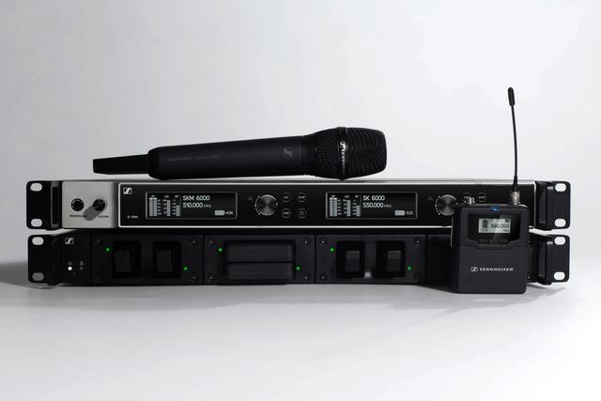
Sennheiser Digital 6000

Wireless microphones are one of the most important elements of these types of shows. Each and every artist and host uses a wireless microphone, so it’s essential to use a system that is reliable. James Stoffo is the RF Coordinator who managed all of the frequencies for the CMA Awards and can’t stress this enough. “The performers’ physical locations are perpetually changing. There are moving shots from green rooms using both host and artist wireless microphones. This can only be accommodated by the use of wireless systems with incredible range and audio quality,” Stoffo says. “My role is to maximize chances for success of all RF operations using my engineering craft and 36 years of experience in the field. I must choose the proper equipment and implementation thereof.“

Stoffo continues, “My goal is to determine the expectations of production and accommodate them. Specifically in the case of this year's show, we were required to run exceptionally long coaxial cables so that one of the numbers could start in a green room quite far from my wireless receiver rack. I used a Sennheiser combiner with Sennheiser [A2003-UHF] low gain antennas. As the antennas had to be low profile as they were in the camera shot, I chose two Sennheiser Log Periodic Dipole Arrays for the gain and radio Frequency coverage. “

Having the right headphones to monitor all of the wireless microphones during the show is also an important component. “My choice is a set of Sennheiser HD 650s for many reasons,” Stoffo says. “First off, I am wearing the headphones for four hours straight with no breaks. The Sennheiser HD 650s are comfortable and adjustable to fit well. Secondly, the audio quality is outstanding and I have not had the headphones distorted. Finally, the open-air nature of the headphones allows me to monitor all of the wireless microphones while retaining the ability to simultaneously communicate with my backstage audio team. I even insert the intercom audio panel into my mix so that I can monitor comms as well. “

A longtime partnership
Kelsea Ballerini, who was nominated for Female Vocalist of the Year and Musical Event of the Year, also made a showstopping appearance at the ceremony. And like Gardner, her FOH Engineer Chris Diener also enjoyed preparing for the live broadcast. “The shows are always so great about us bringing our handhelds,” Diener says. “We simply let them know we are bringing them along and what frequency band, and they provide a receiver for us ... We had more than one engineer on the show tell us how well-suited the system was to Kelsea’s voice. We love getting the compliment of, ‘you guys have the perfect mic for her.’”

For tour, Ballerini’s team is loyal to Sennheiser’s Digital 6000 and the MD 9235 dynamic microphone capsule. “The system has been incredibly robust, always sounds great and it always shines in front of a PA on a thrust. We try to take these everywhere we go, and it always performs,” says Diener. “We have been so well taken care of by Sennheiser. Anything we have needed, they have gone above and beyond for us!”

Stoffo also acknowledges the ease provided by Sennheiser support: “On any live event, the RF Coordinator is expected to handle multiple wireless systems from multiple manufacturers. Real-time technical support from the manufacturer is crucial to the success of the show. Having Sennheiser support on-site leading up to the show is beneficial and the Sennheiser support team is always ready to provide any last-minute accessory items required.”

“My touring package is 90% Sennheiser – our entire drum package is Sennheiser.” Gardner says of Jelly Roll’s tour, before noting that it’s also about the dependability of the team: “Tim Moore is always good if we get into a pinch and need some last-minute capsules. I can reach out to him and he’ll make it happen,” he says.

Jelly Roll’s Beautifully Broken US Tour wraps in Nashville, TN on November 26th before the Canadian leg kicks off in the spring. He is also set to headline Stagecoach Festival and join Post Malone on tour in 2025.

Image Source IMAGO / UPI Photo

About the Sennheiser brand
Building the future of audio and creating unique sound experiences for our customers - this is the aspiration that unites the employees of the Sennheiser Group worldwide. The independent family-owned company Sennheiser was founded in 1945. Today, it is managed in the third generation by Dr. Andreas Sennheiser and Daniel Sennheiser, and is one of the leading manufacturers in the field of professional audio technology.

sennheiser.com | neumann.com | dear-reality.com | merging.com

Local Press Contacts
Daniella Kohan
daniella.kohan@sennheiser.com
+1 (860) 227-2235

Kirsten Spruch
Kirsten.spruch@sennheiser.com
+1 (860) 598-7484

